1. Create a class to handle the Arithmetic Exception. The output should be “You can’t divide a number by 0”. Use try -catch block

package Exception;

class ArithematicException {

public static void main (String args[]) {

int num1 = 15, num2 = 0, result = 0;

try{

result = num1/num2;

System.out.println("The result is" +result);

}

catch (ArithmeticException e) {

System.out.println ("You can’t divide a number by 0 " + e);

}

}

}

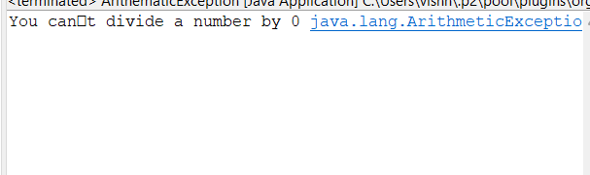

1. Create a class to handle ArrayOutOfBoundException. Give the size of array as 5. Try to access 7th element. The output should be “Array is out of Bound”

package Exception;

public class ArrayOutofBoundException {

public static void main(String[] args) {

int a[]= {1,2,3,4,5};

int i;

try

{

System.out.println("Array contains");

for(i=0;i<7;i++)

{

System.out.println(a[i]);

}

}

catch(ArrayIndexOutOfBoundsException e)

{

System.out.println("Array index out of bound");

}

}}

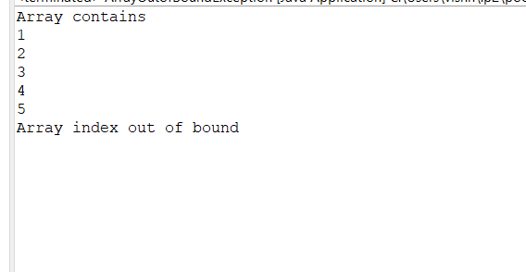

1. Create a class and throw Arithmetic Exception.(use throw and throws)

package Exception;

import java.util.Scanner;

class UsingThrow {

public static void main(String[] args) {

Scanner s = new Scanner(System.in);

System.out.println("Please enter your roll number");

int roll = s.nextInt();

if (roll < 0) {

throw new ArithmeticException("Roll number can't be negative");

} else {

System.out.println("Valid roll number");

}

}

}

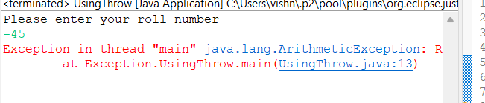

package Exception;

public class UsingThrows {

static void checkrollnumber(int num) throws ArithmeticException {

if (num < 0) {

throw new ArithmeticException("Roll number cant be negative");

} else {

System.out.println("Roll number is valid");

}

}

public static void main(String[] args) {

checkrollnumber(-15);

}

}

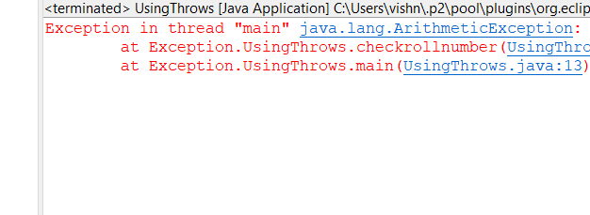

1. Create a custom Exception class to handle invalid age.(Age less than 18)

package Exception;

public class AgeCheck {

static void checkAge(int age) throws ArithmeticException {

if (age < 18) {

throw new ArithmeticException("Age is invalid");

}

else {

System.out.println("Age is valid");

}

}

public static void main(String[] args) {

checkAge(-23);

}

}

